Housing Element/

2023-2024 Annual Action Plan

Community Meeting

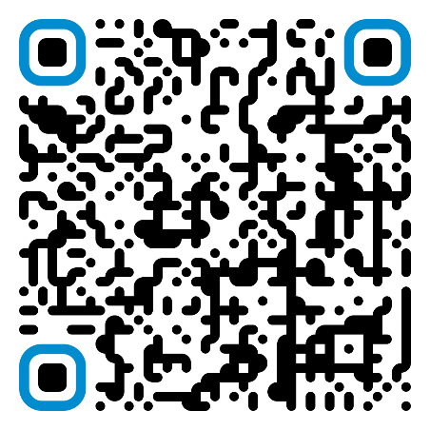Scan the QR code to receive updates about the Annual Action Plan and other Housing and Community Development information.

You can also email [Casey.Lauderdale@fresno.gov](mailto:Casey.Lauderdale@fresno.gov) to receive updates about the Housing Element.

Goal: Homeless and Homelessness Prevention

Goal: Affordable Housing

Goal: Public Infrastructure and Facilities

Goal: Public Services

Goal: Fair Housing

Housing Element: